STANDARD AIR KIT DOC….. WWW.X2INDUSTRIES.COM
Front to back much of the difference between our air suspension systems are in the air management equipment, the process between our air ride system installation techniques are very similar.
VALVE PLUMBING OPTIONS:
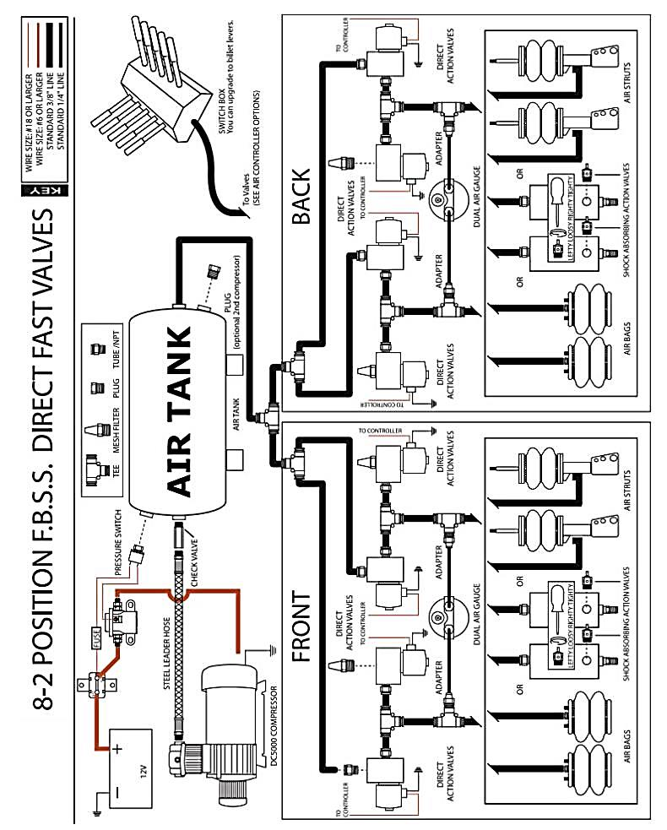
Previous Standard Systems used a few t-fittings to accomplish what the below configuration does with much less plumbing and airline.
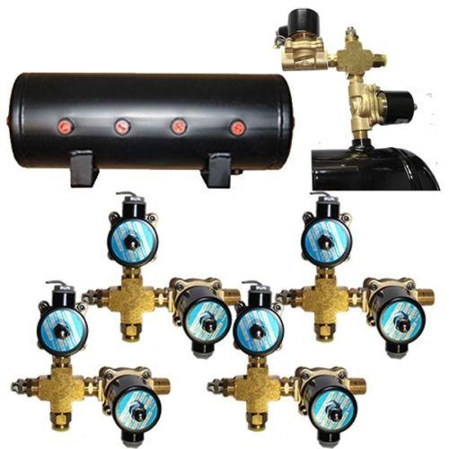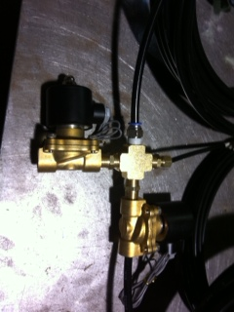
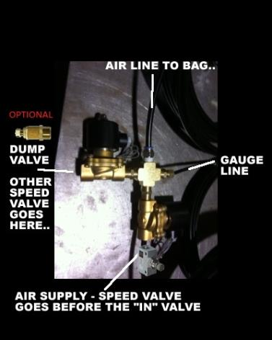
Air suspension utilizes 2 valves for fill and dump, per corner. Your 8 individual valves will work in sets of 2 for 4 wheels. The above illustration shows the installation of the valves on the 4 side mounted port 3 gallon air tank.
COMPRESSOR WIRING AND PLUMBING:
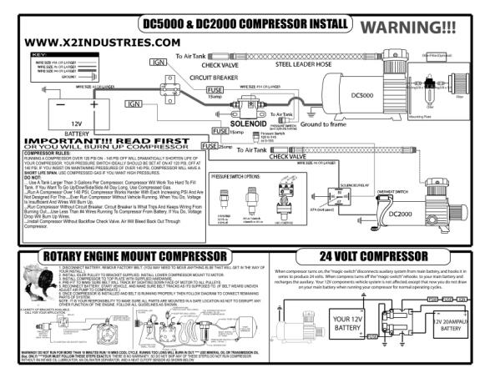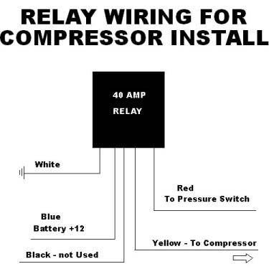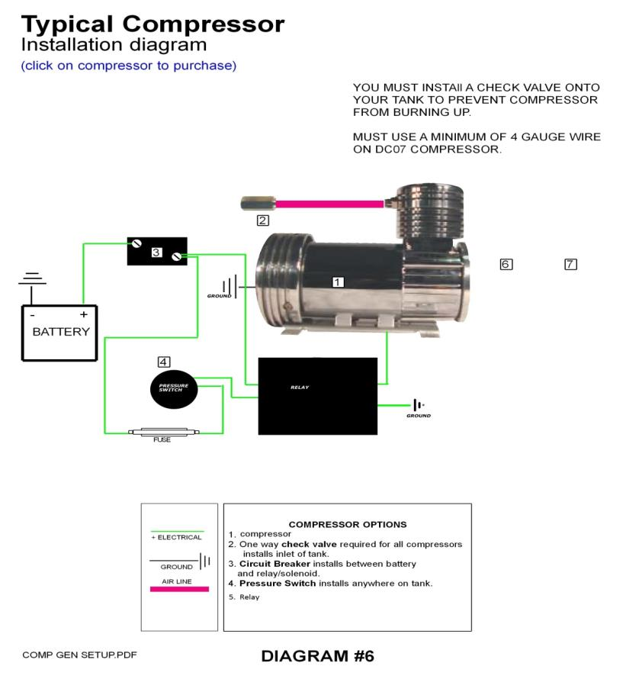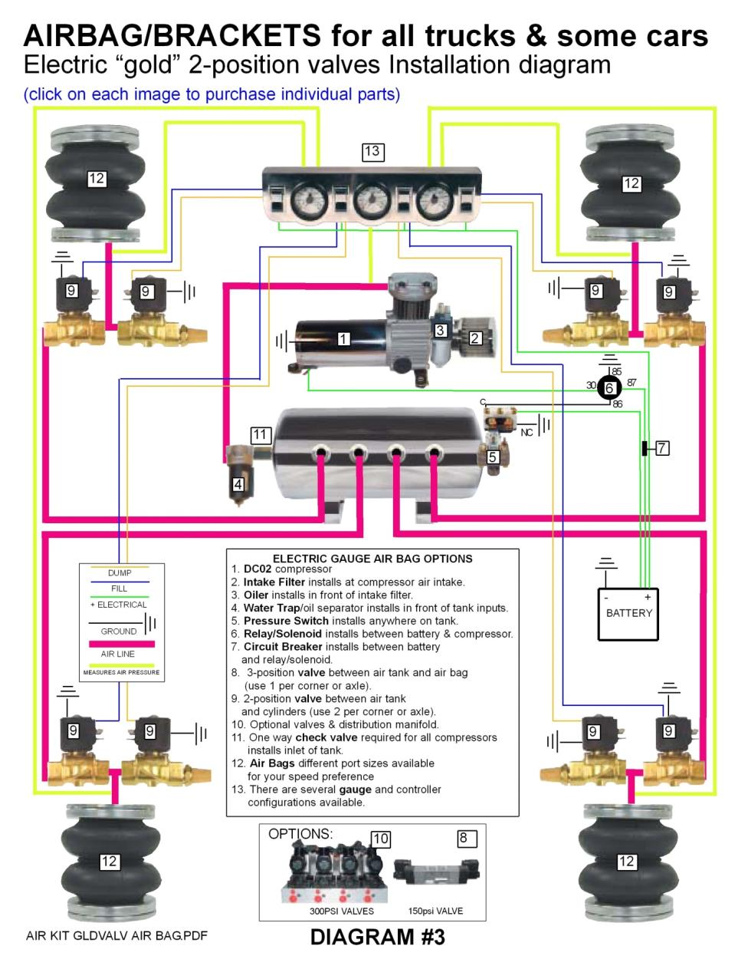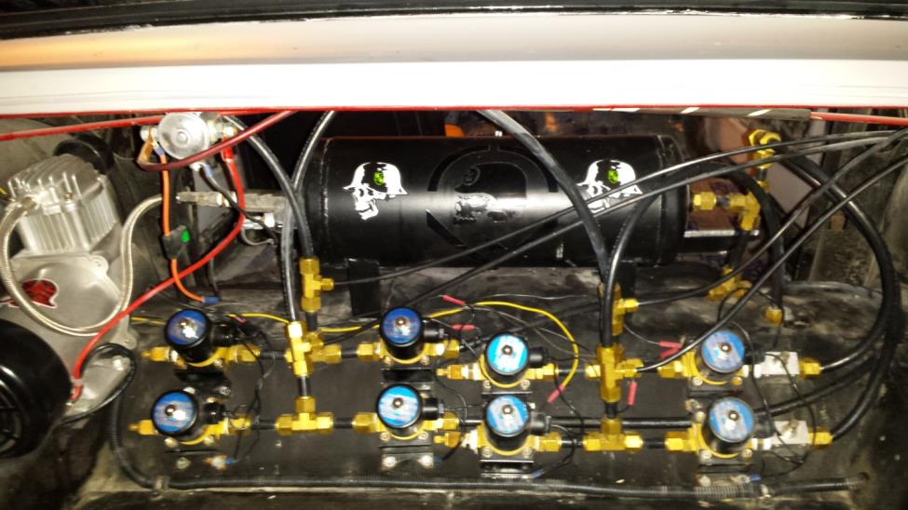
When installing your compressor you will need an amp kit minus the RCA’s from the kit for the power to your system.
Parts needed when wiring up your compressor are “relay”, “pressure switch”, “main 12 volt power lead”, “ground” and a thinner “remote trigger power wire”
Diagram number six above gives you a general idea of how these parts will work in unison to provide your system with maintained air pressure.
The steel braded airline that connects from your compressor to your tank has a larger end which will be at the tank side, this larger end houses a check valve to ensure the air does not leak from the tank back into the compressor and out.
GAUGE PANEL TO VALVE WIRING:
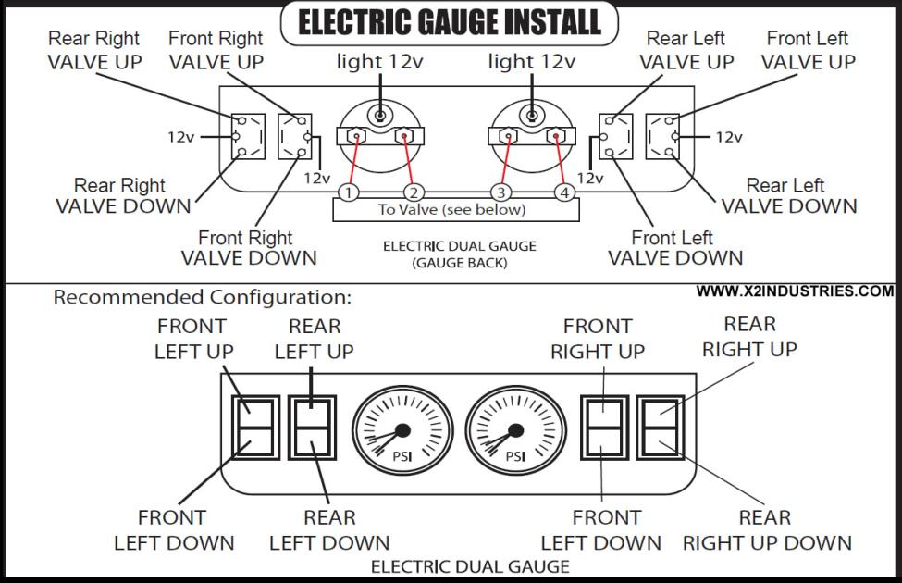

REAR CHASSIS COMPONENTS:
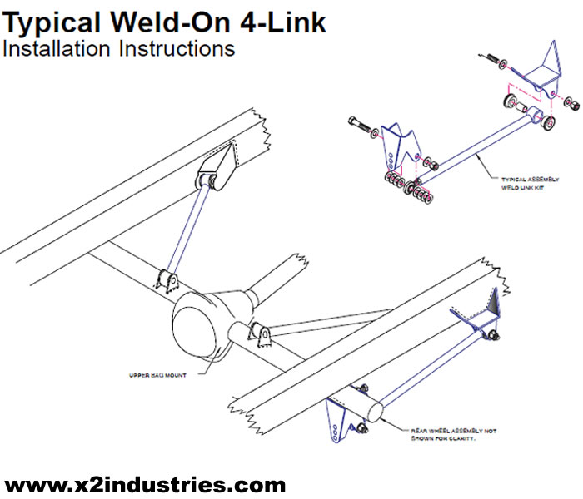
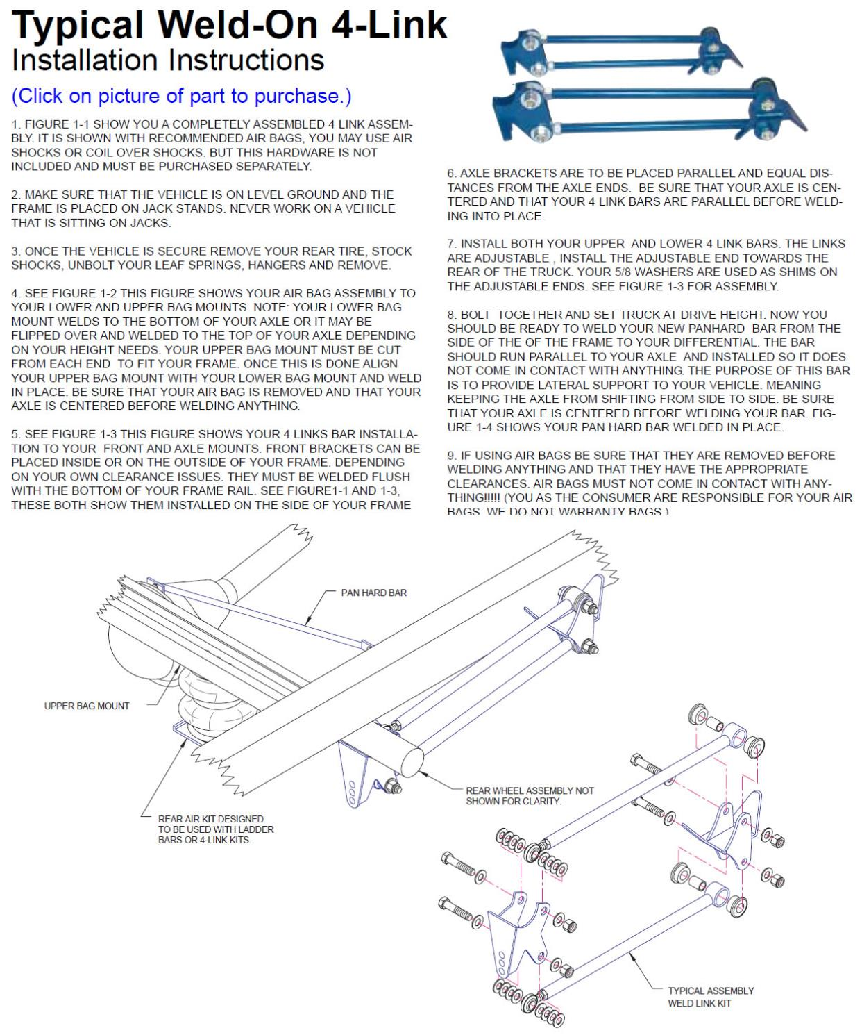
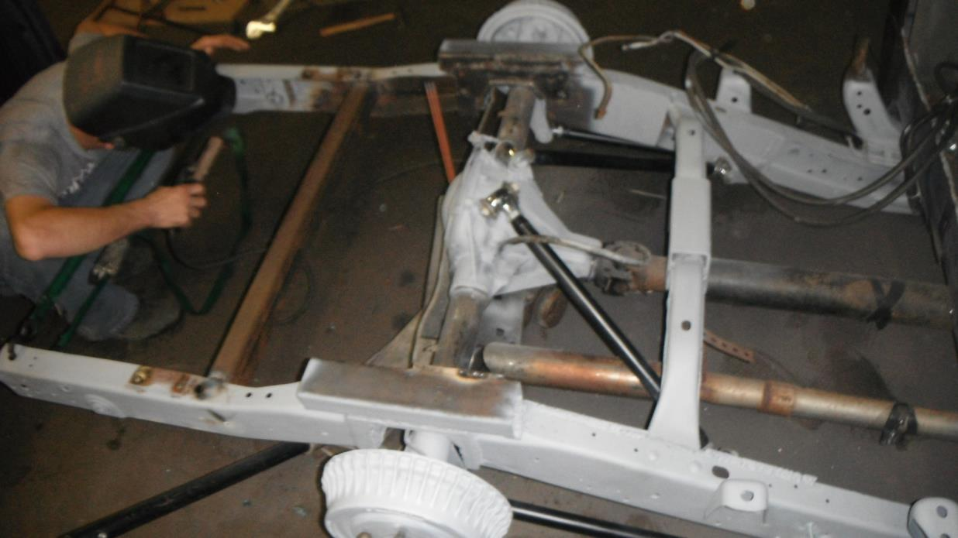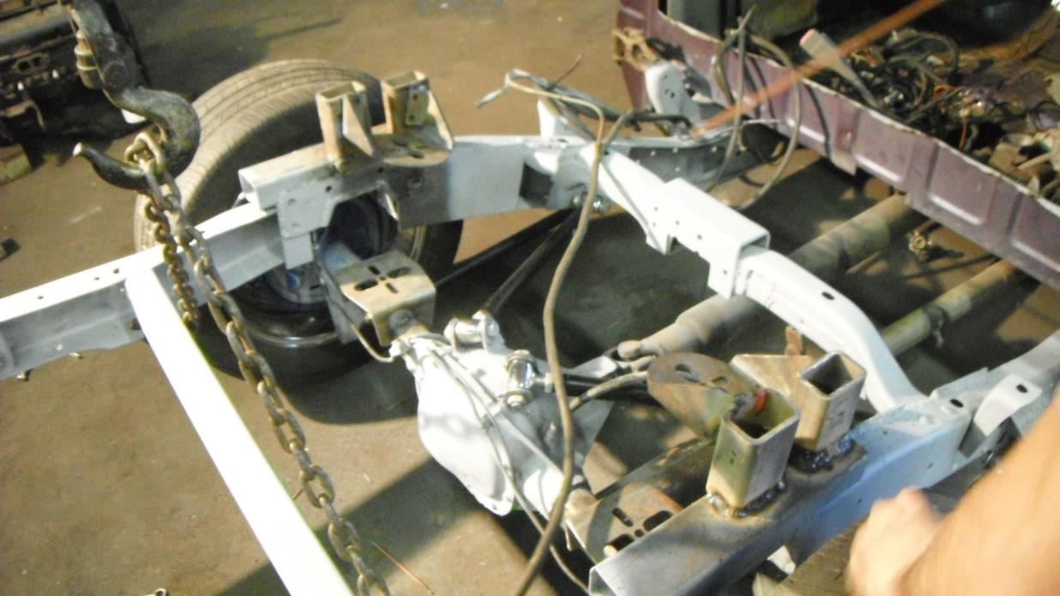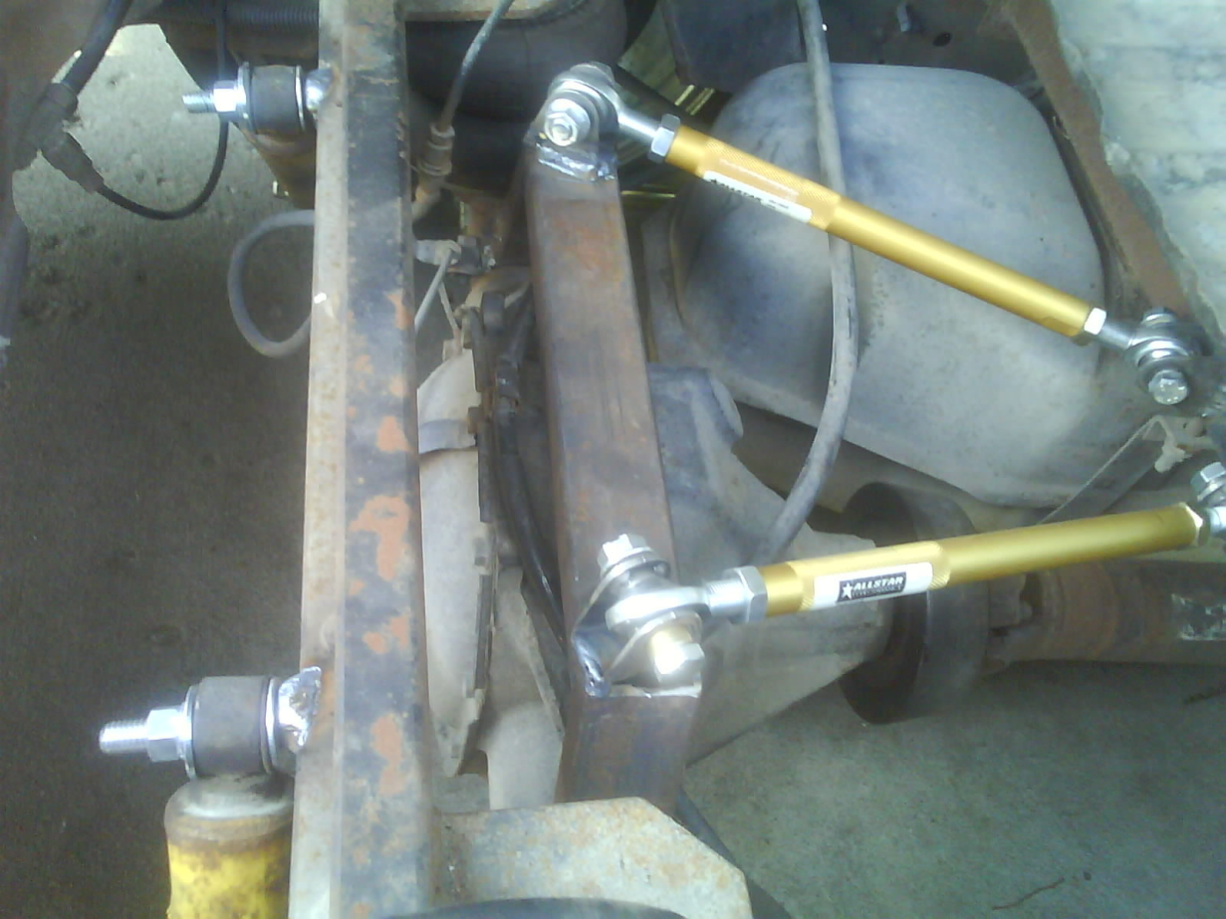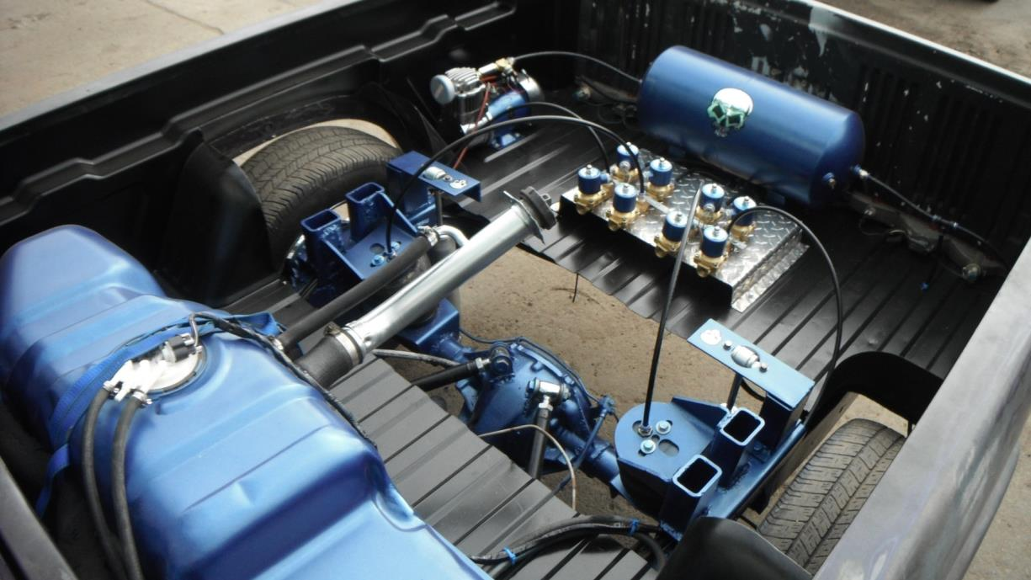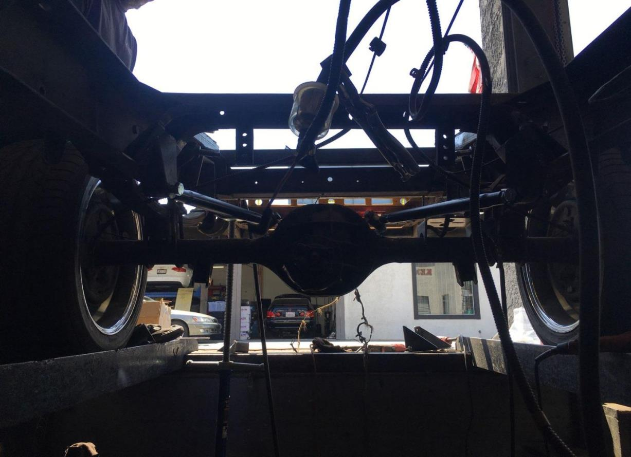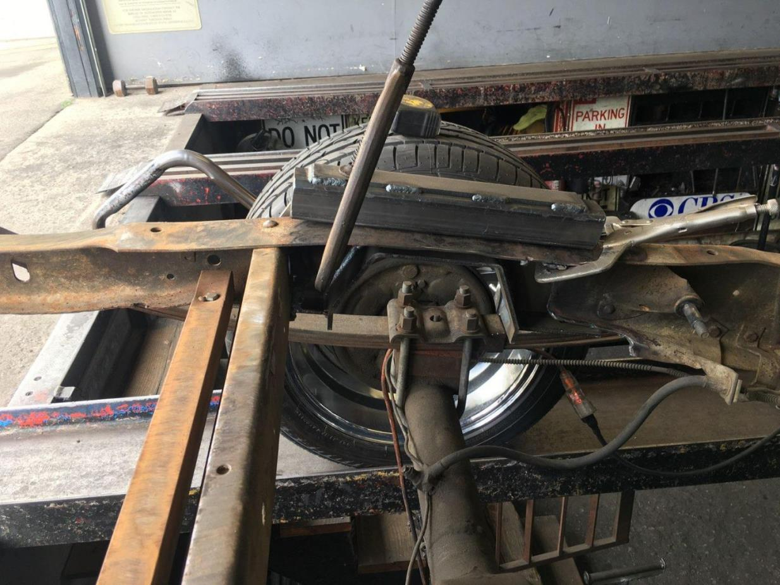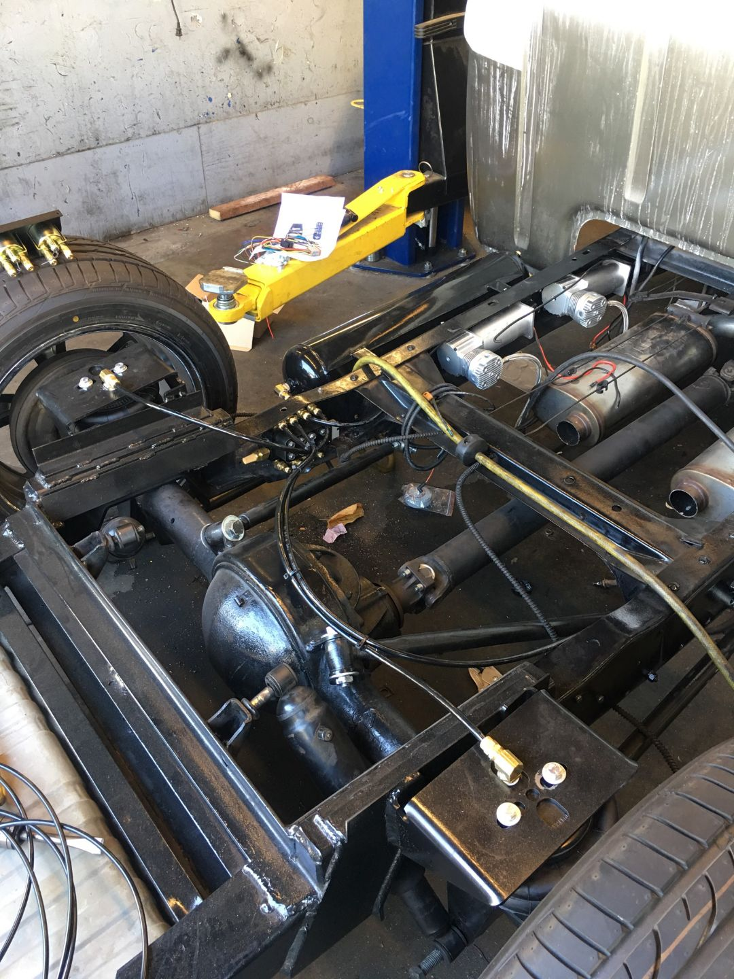
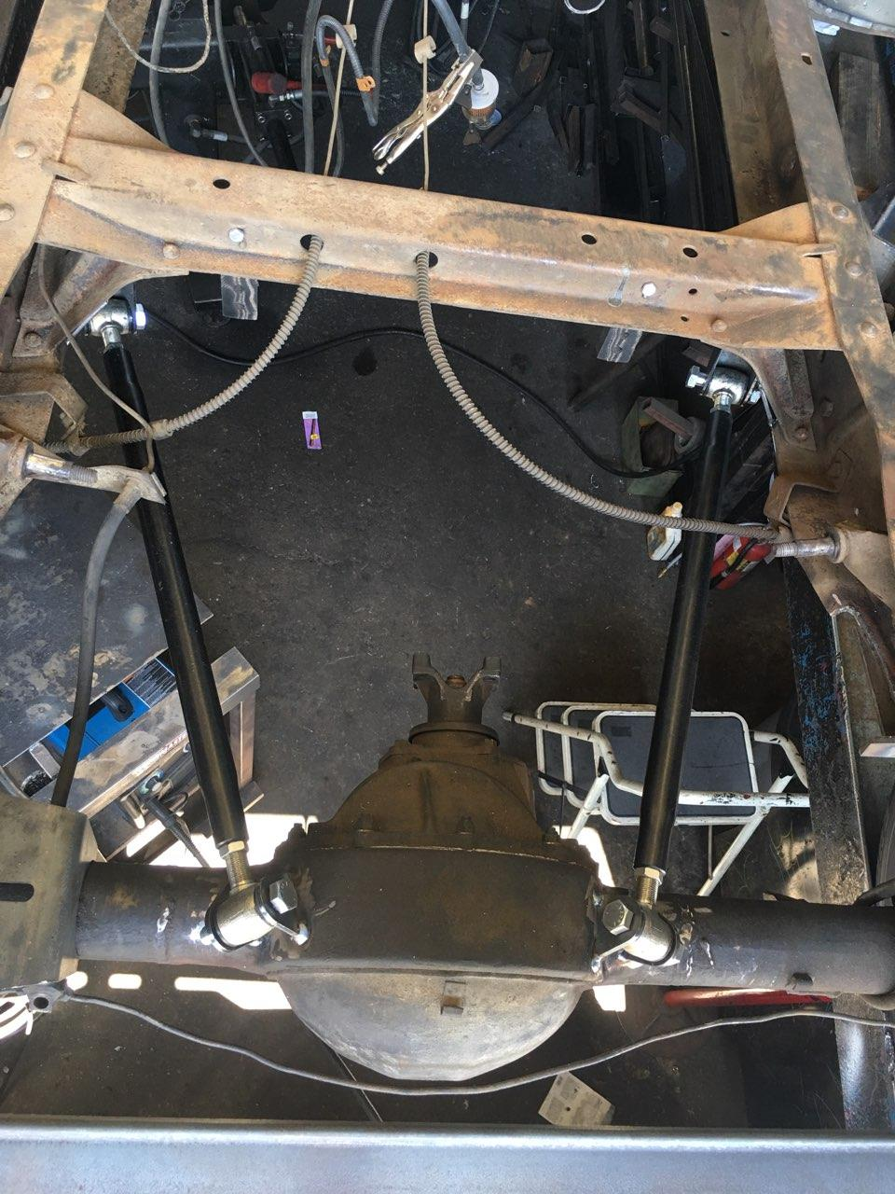
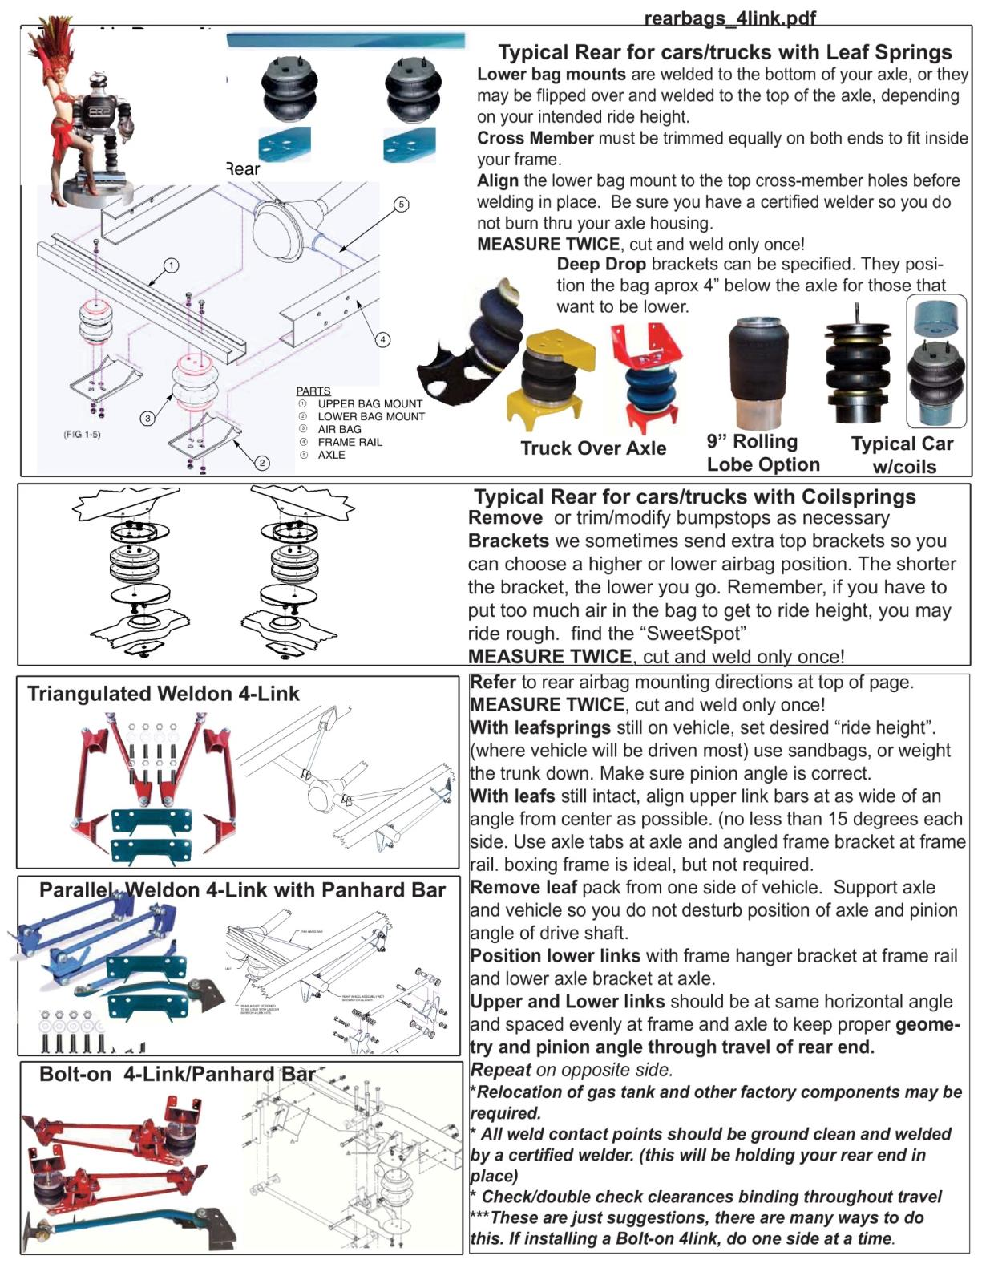
FRONT CHASSIS COMPONENTS:
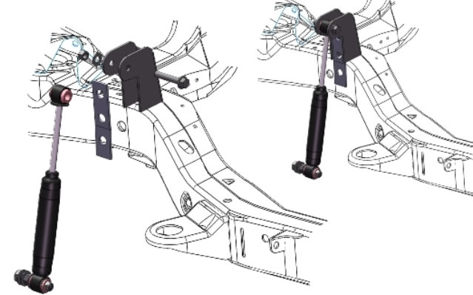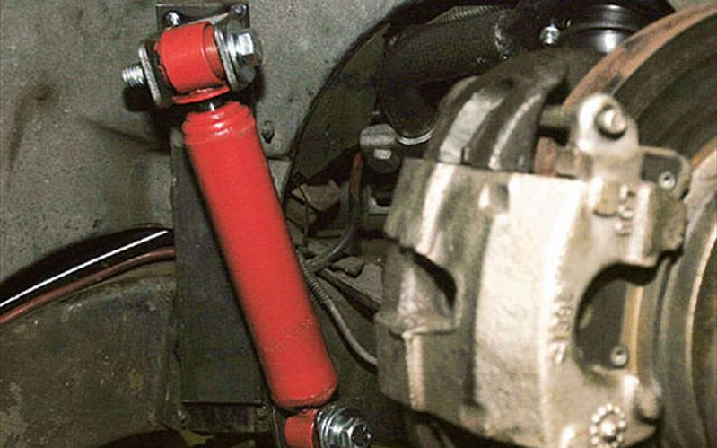
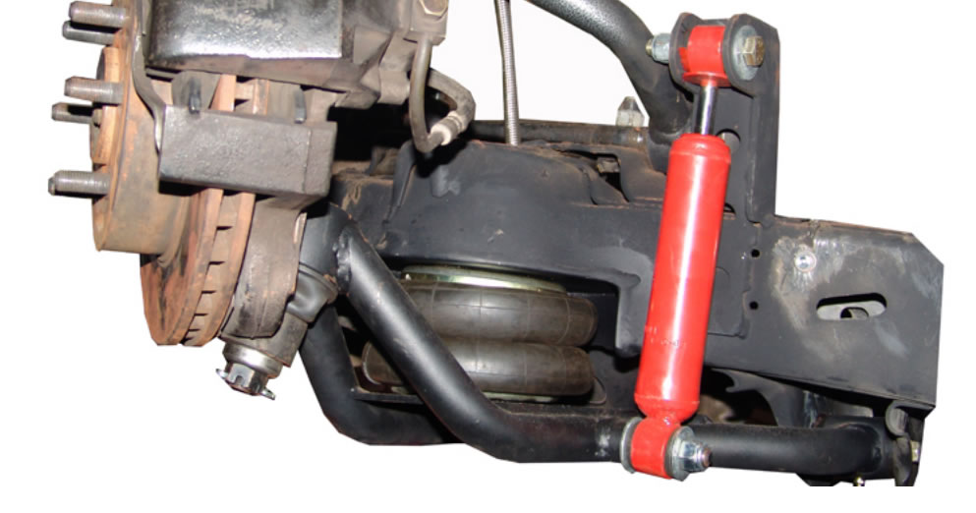
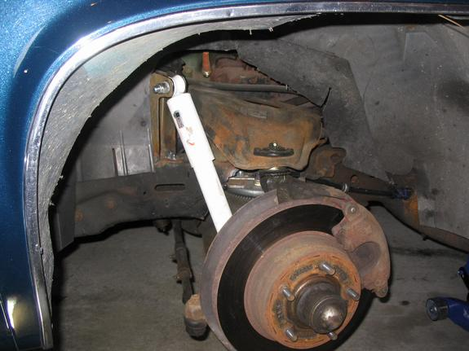
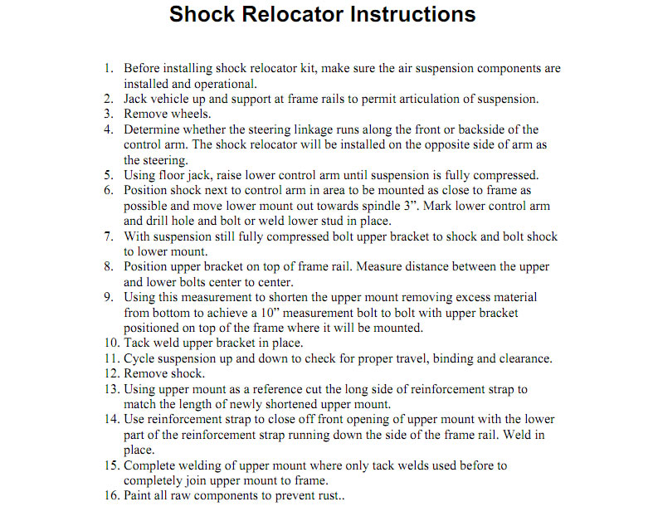
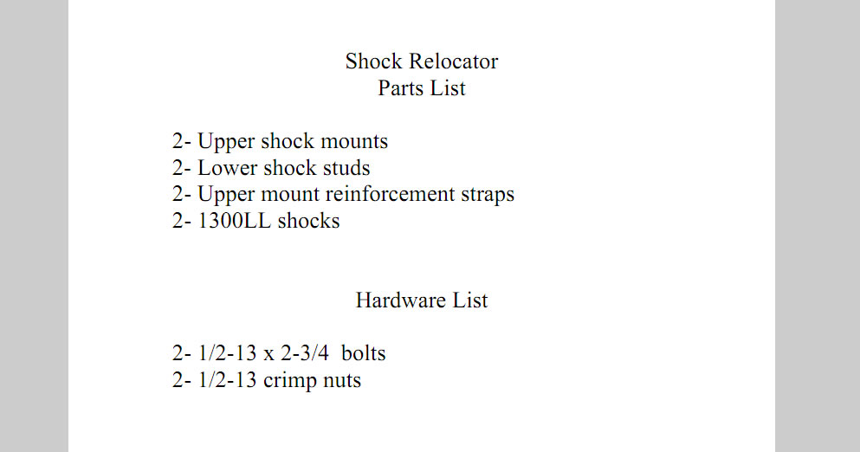
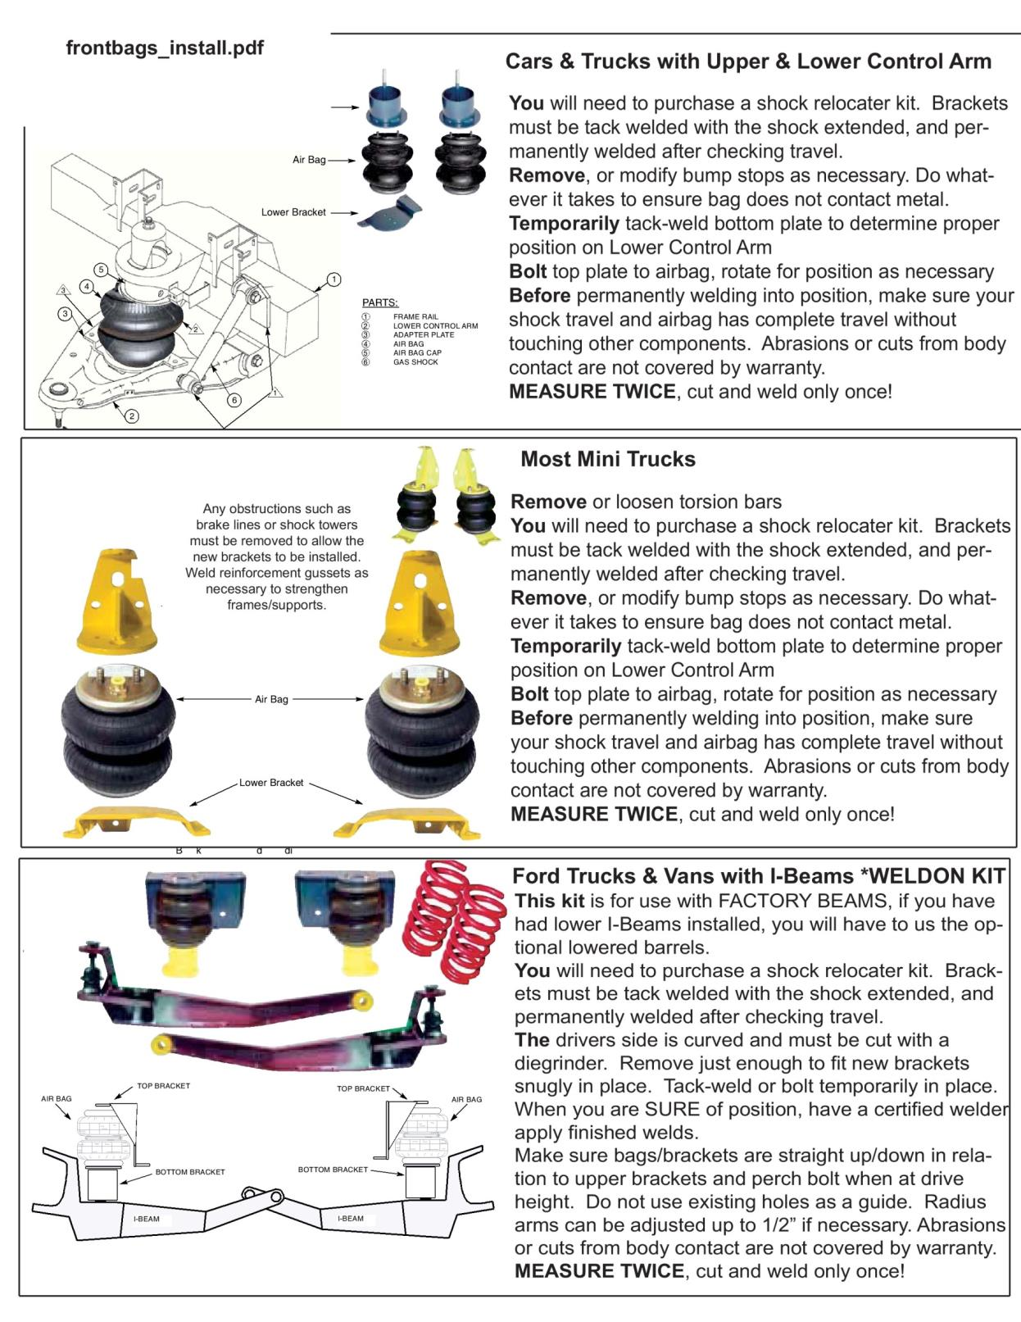
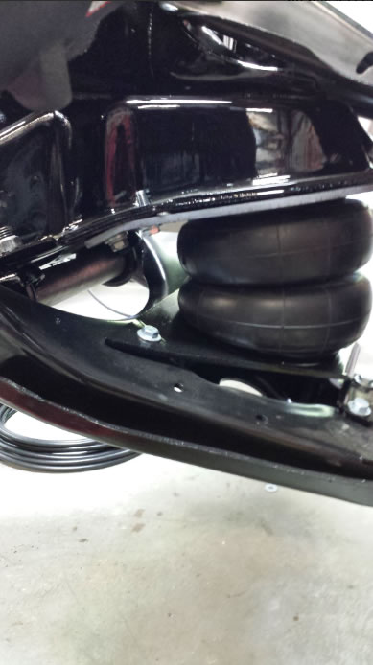
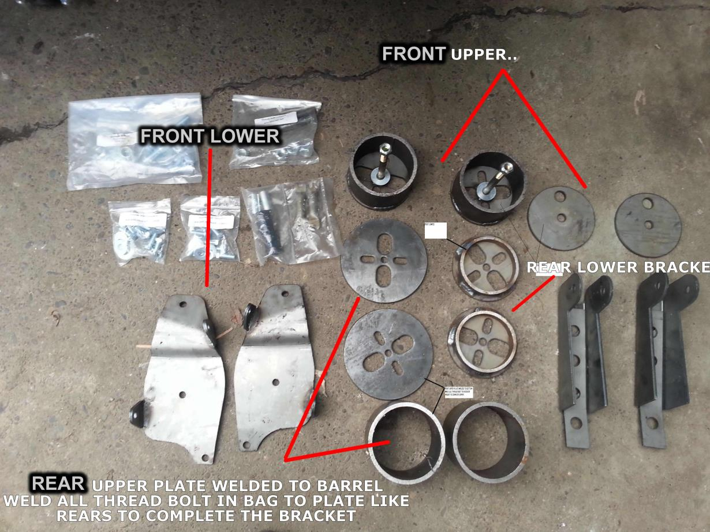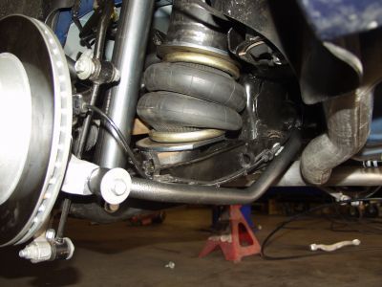
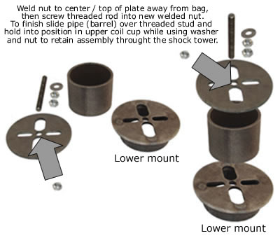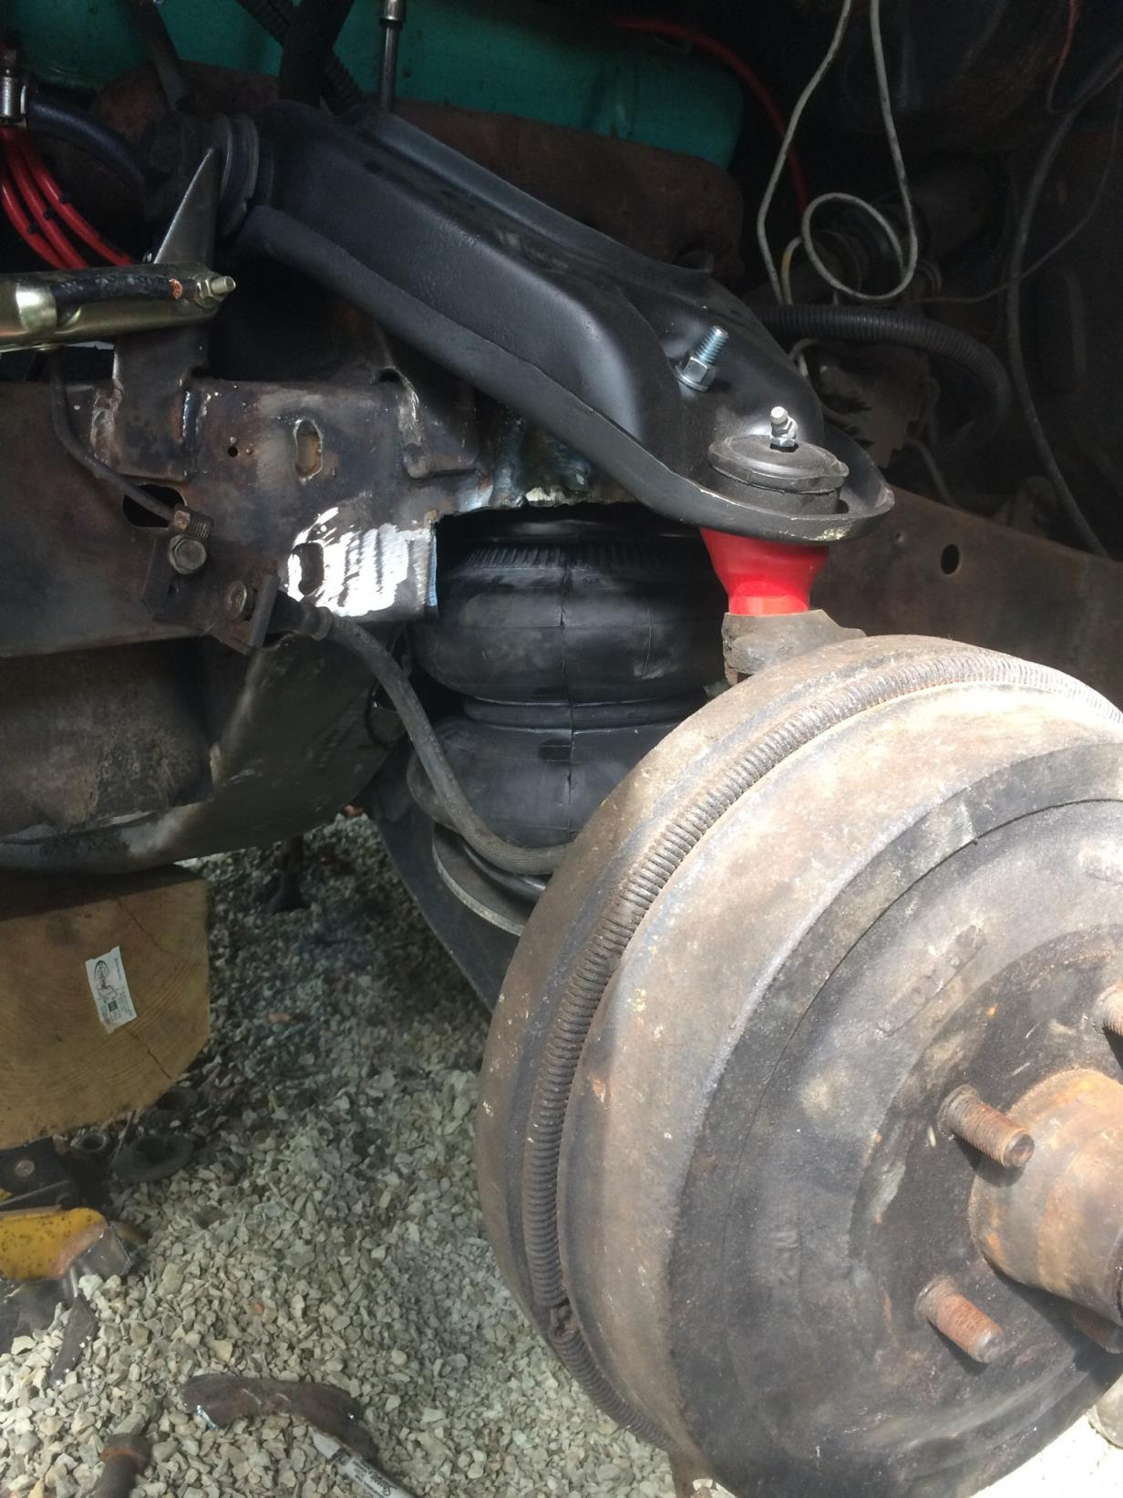
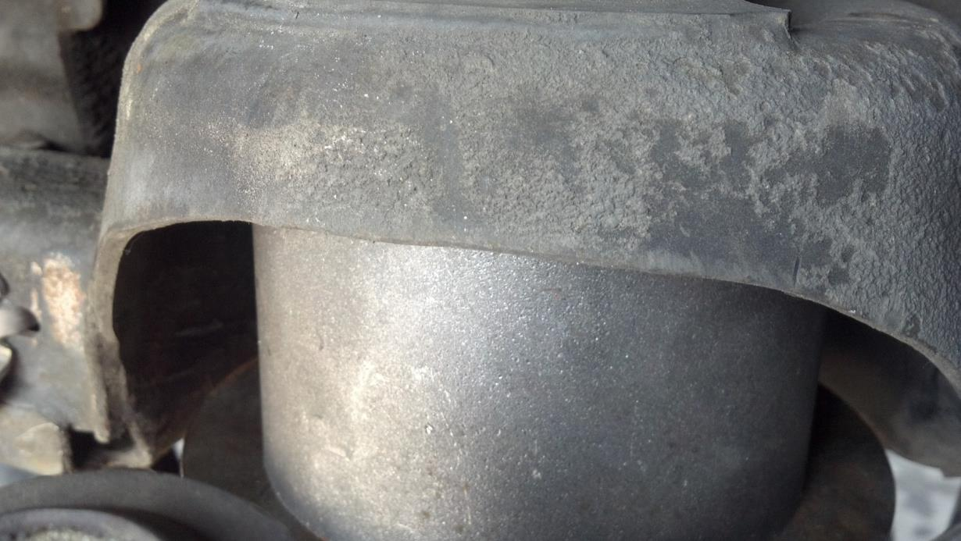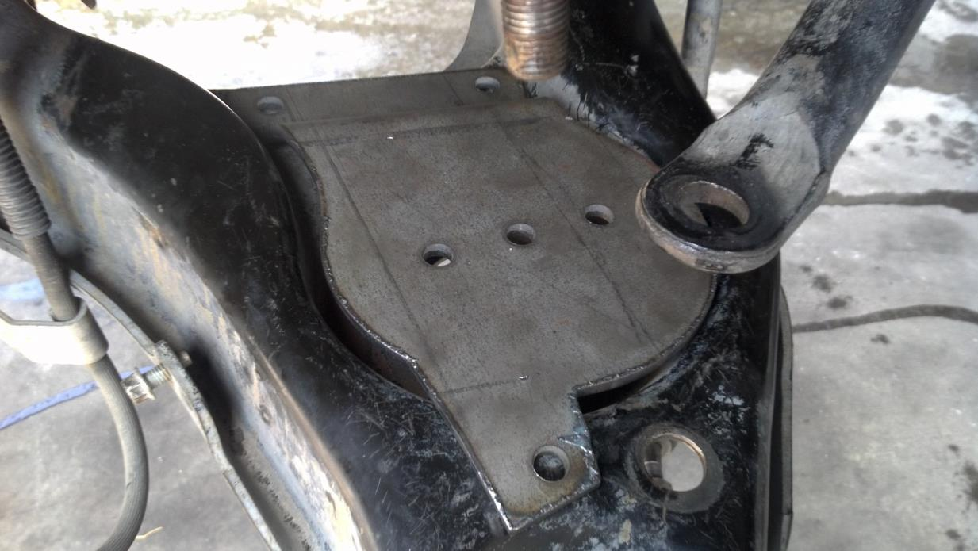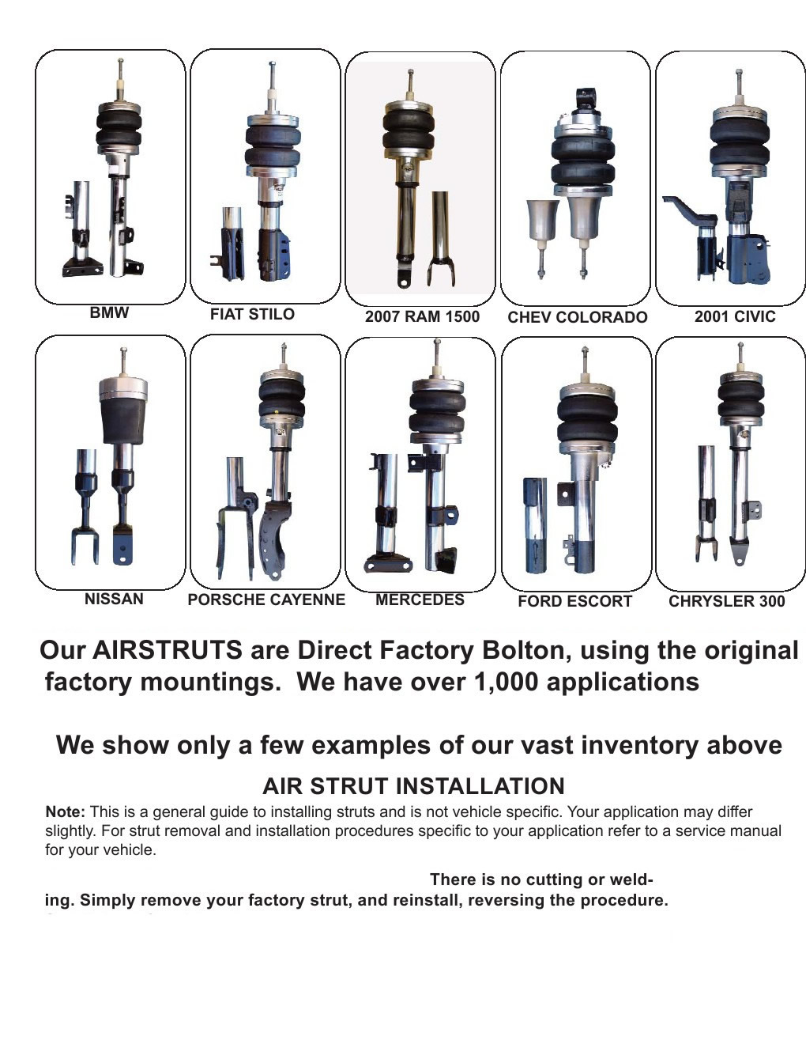
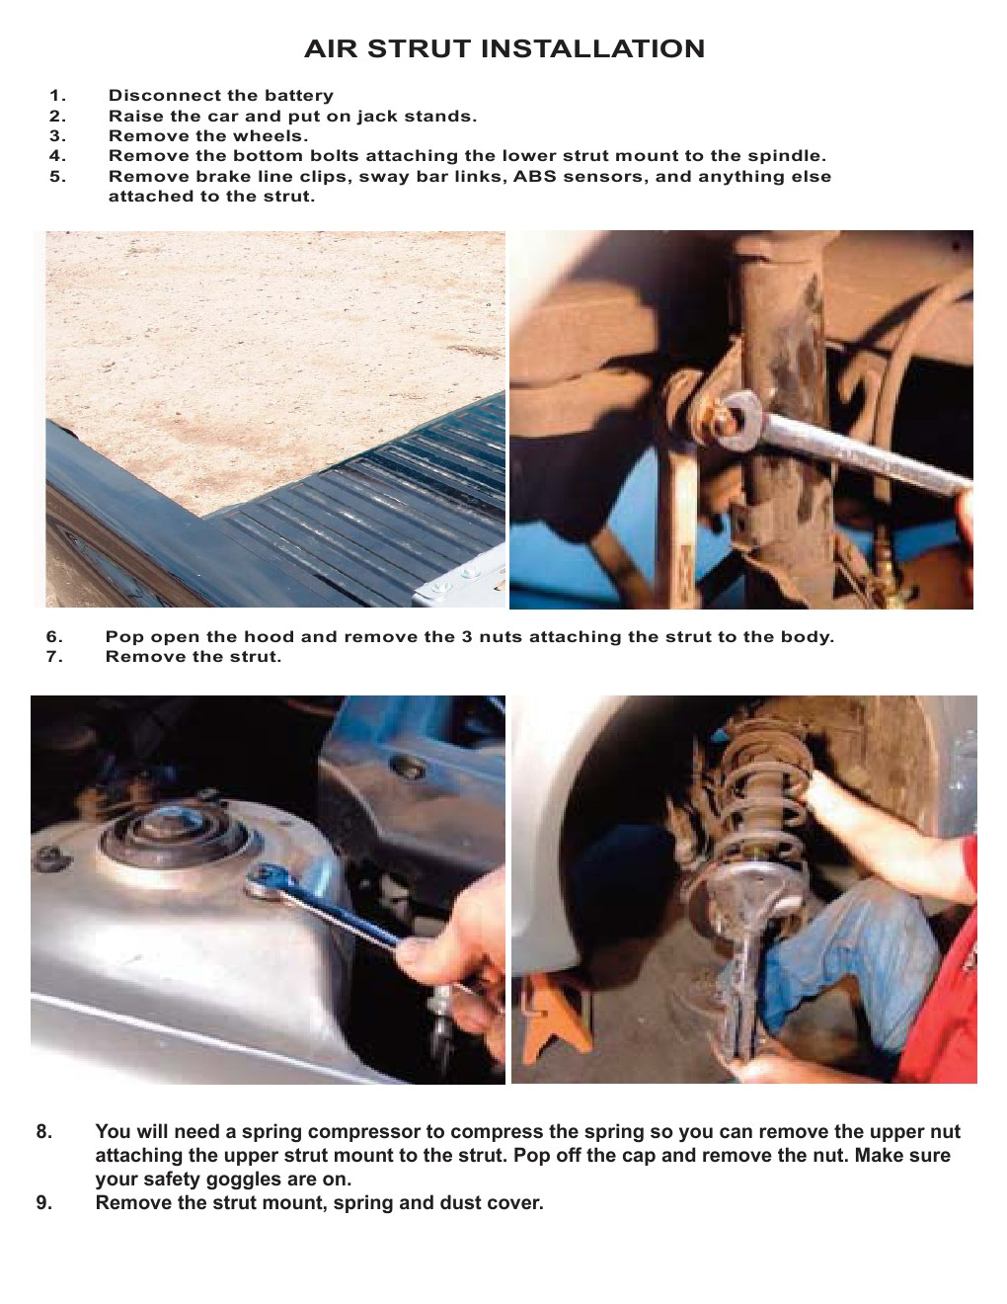
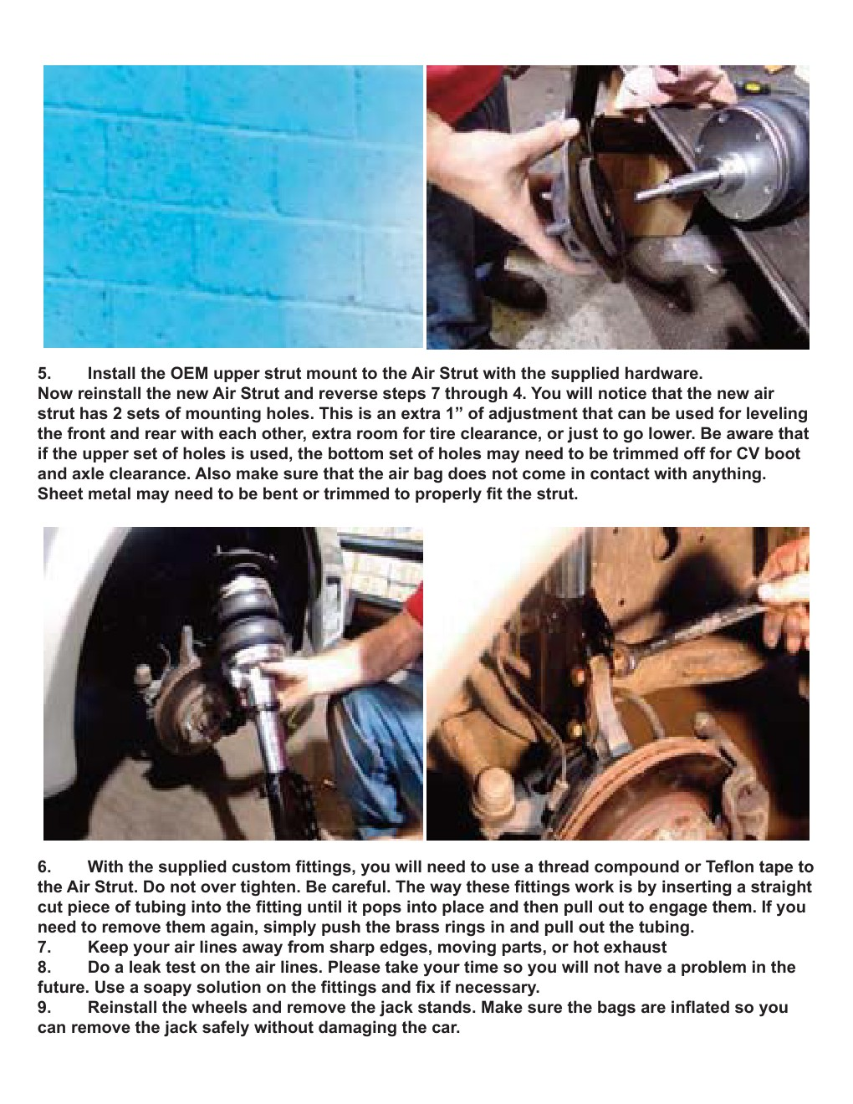
CARTRIDGE STYLE STRUT INSTALLATION:
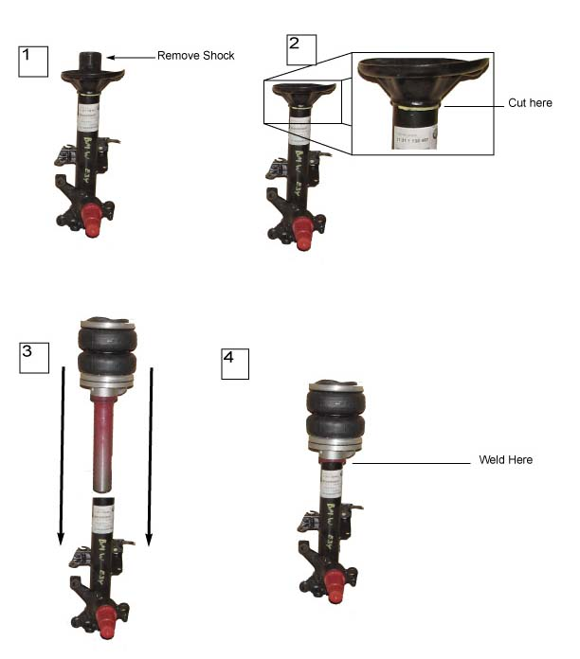
****THE LOWER SECTION OF THE STRUTS THAT USE THE FACTORY CARTRIDGE IS TRIMMABLE***
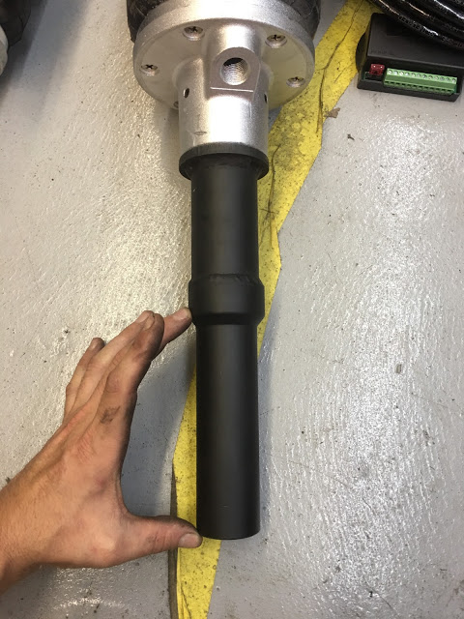
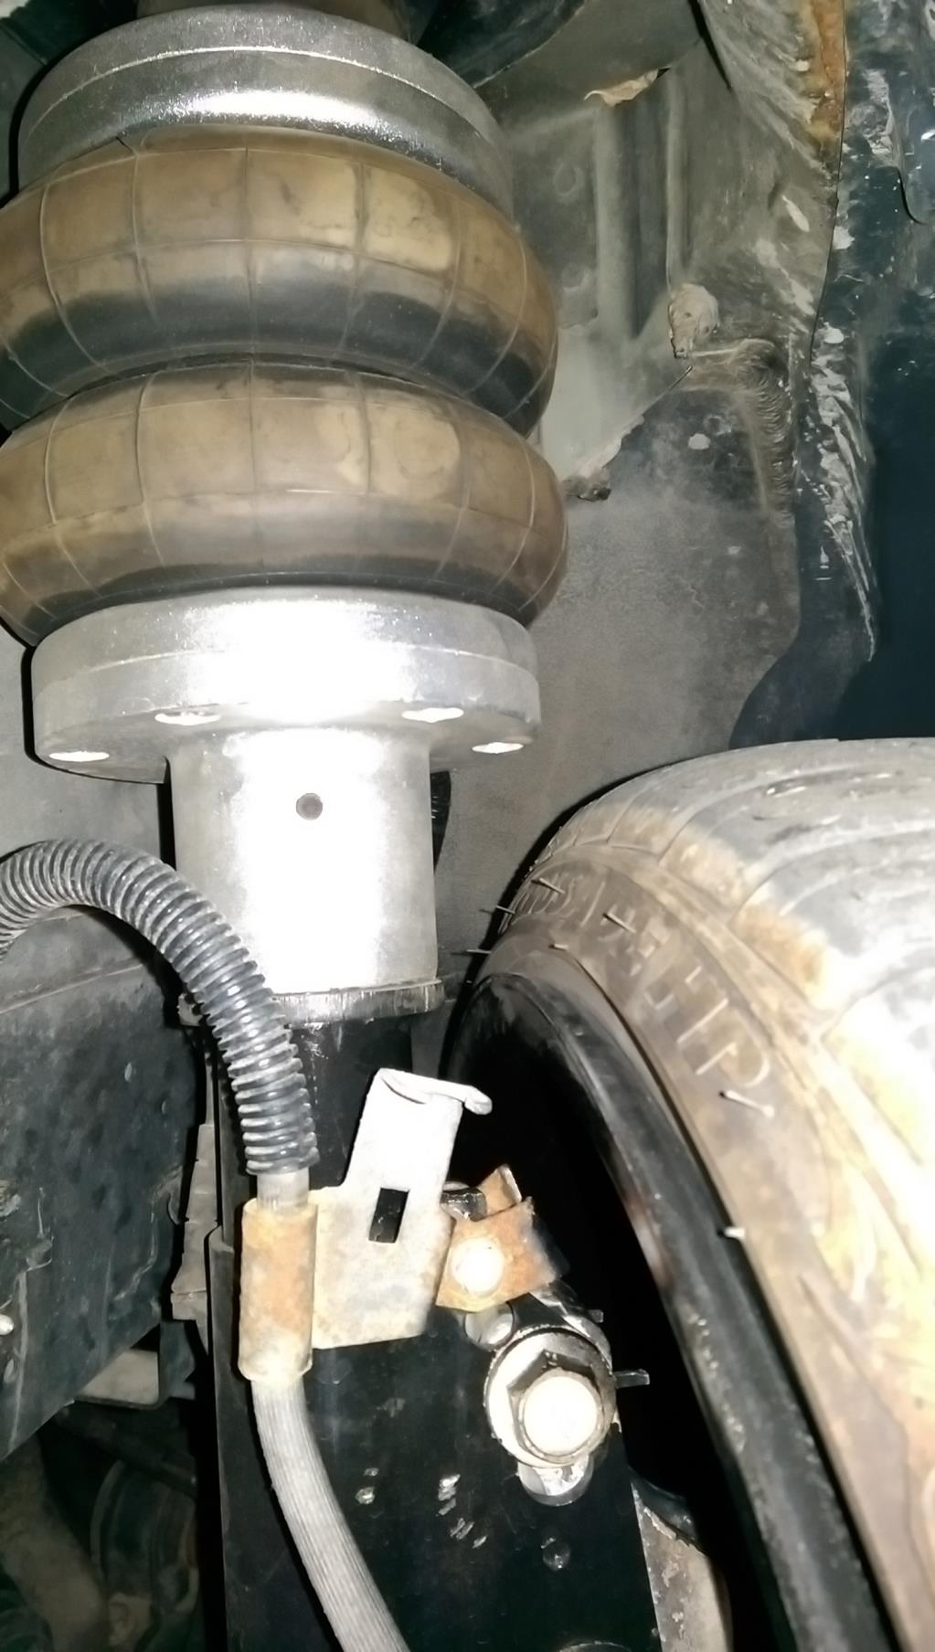
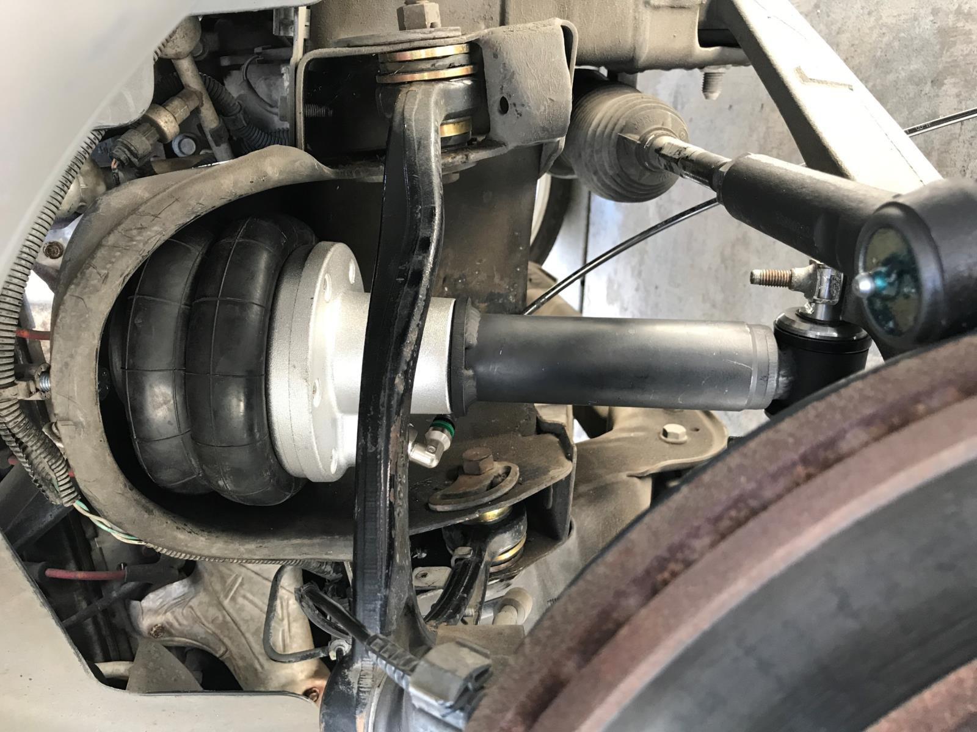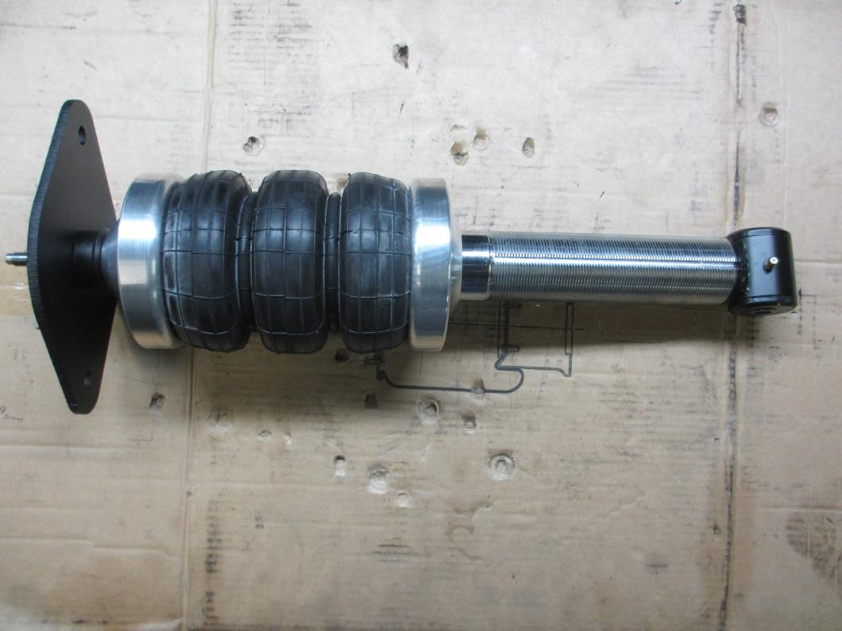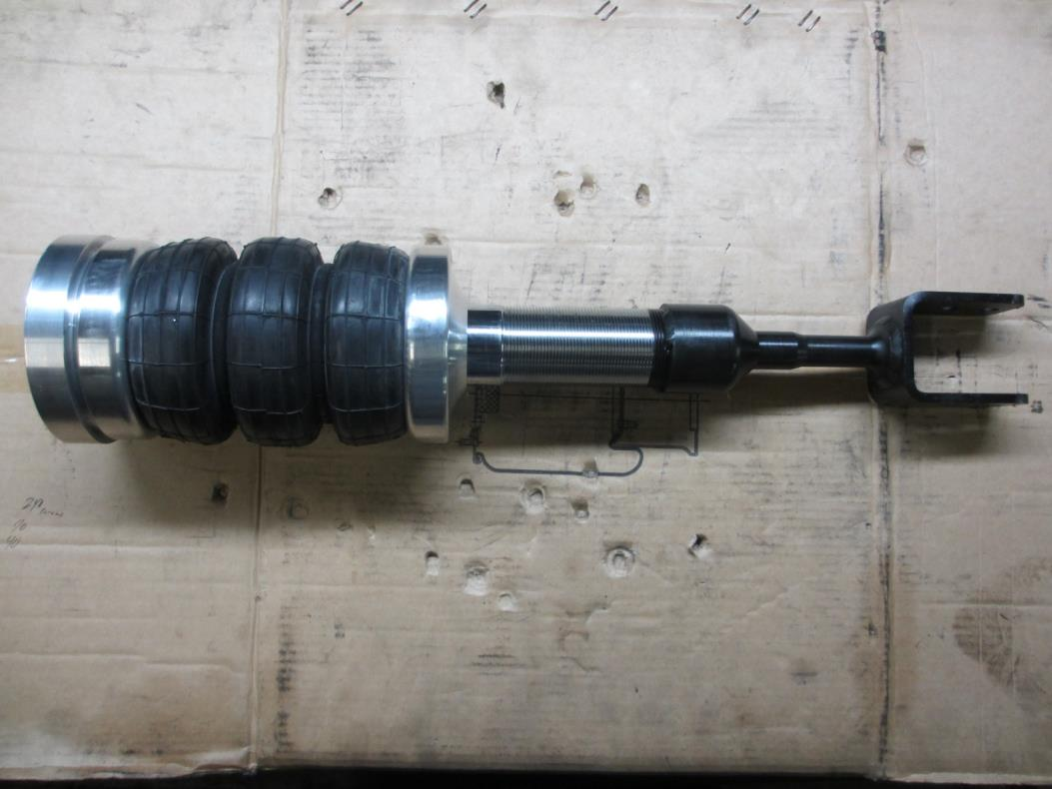
STILL HAVE QUESTIONS? PLEASE GIVE US A CALL AT: 1-800-823-0230
KNOWLEDGABLE REPRESENTATIVES ARE WAITING TO HELP.

www.X2INDUSTRIES.COM

sales@x2industries.com

inquiry@x2industries.com

